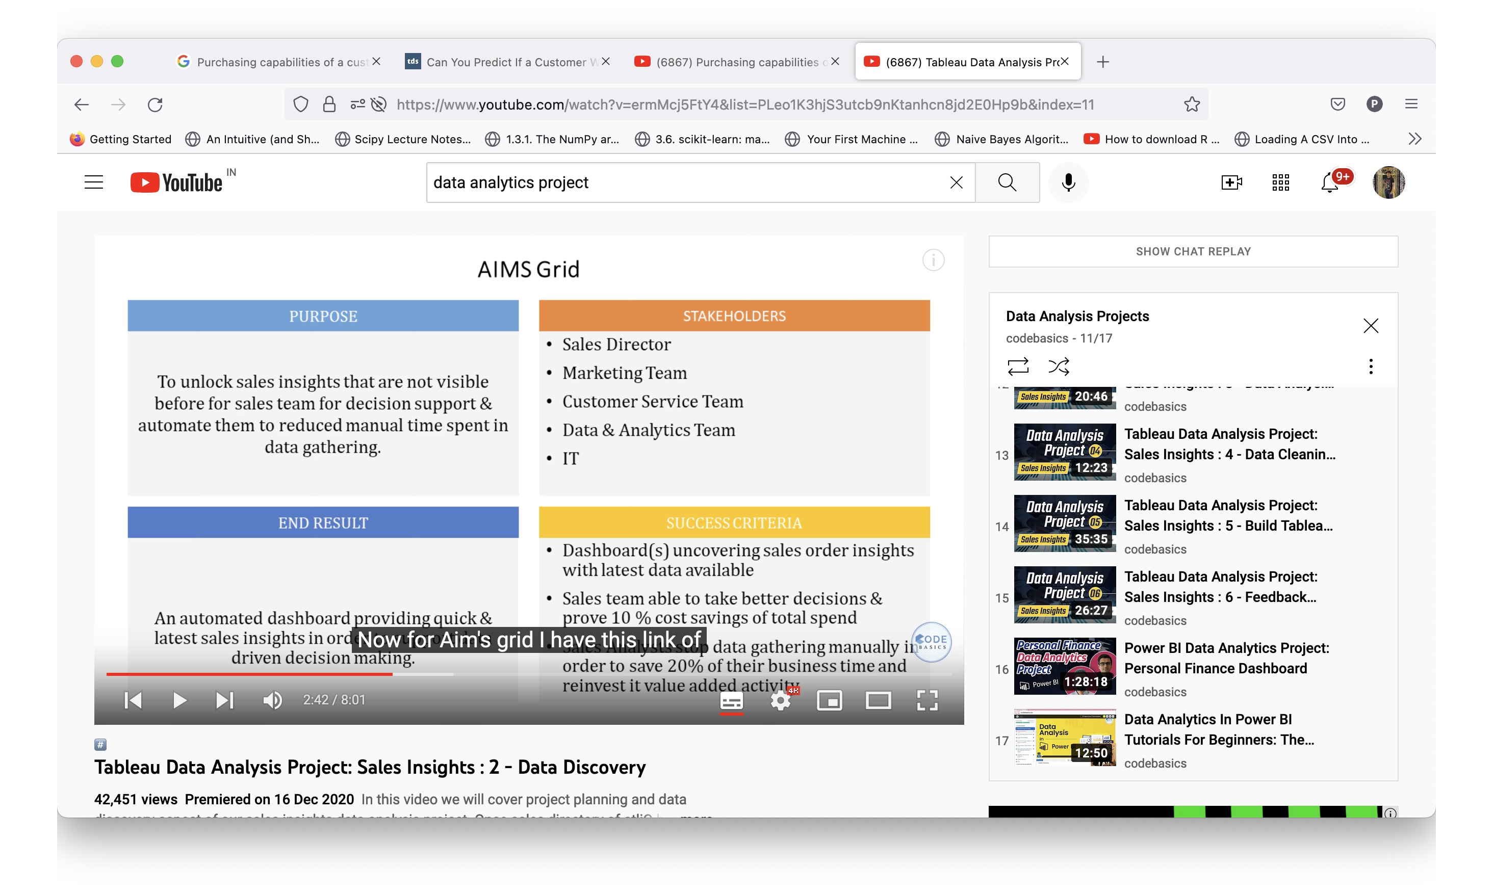



Industry 🡪 Domain Knowledge



1. Remove irrelevant data (Identify the data we need, and we don’t need)
2. Remove extra spaces and blanks.
3. Fix mis-spelling
4. Inconsistent capitalization
5. Incorrect Punctuation and other typos
6. Remove Formatting
7. Conditional Formatting
8. Remove Duplicates
9. Format the Date
10. Split the text (delimiter)

Numerical Analysis

1. Average debt of a country in a year